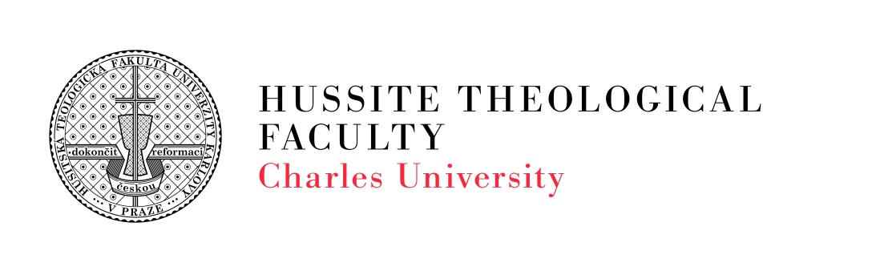

Ref. No.: UKHTF/569416/2026

Assistant Professor in Systematic Theology, Systematic Ethics and Systematic Philosophy
Hussite Theological Faculty, Charles University invites applications for the position of Assistant Professor at the Department of Theology, Theological Ethics and Theological Philosophy.
The appointment will be made in accordance with the Charles University Regulations for Selection Procedures, as amended.

Qualifications and Requirements
Applicants should meet the following requirements:
• a completed Ph.D. degree in Hussite Theology and Philosophy;
• an established and continuous record of scholarly publications and other creative academic activities in the humanities and social sciences;
• experience in research projects and grant activities, including project preparation and implementation;
• priestly ordination and at least five years of pastoral experience within the Czechoslovak Hussite Church (CČSH);
• a minimum of five years of teaching experience and demonstrated ability to teach courses in the following areas: History of Dogma, Philosophical and Professional Ethics (with a focus on Social Work), Foundations of Social Sciences, and Modern Philosophy;
• excellent command of the English language at C1 level, with a minimum of five years of teaching experience and demonstrated ability to teach English as well as humanities and social science courses in English;
• Native-level proficiency in the Czech language.

Employment Details
Starting date: October 2026 (expected)
Employment type: Full-time (1.0 FTE)
Salary: CZK 39,000 per month (Salary Grade AP2, in accordance with the University's internal salary regulations)

Application Materials
Applicants are requested to submit the following documents:
- a letter of application;
- a cover letter outlining their motivation for the position;
- a curriculum vitae, including an overview of previous academic and professional experience;
- certified copies of university diplomas and certificates documenting completed degrees.

Application Process
Applications must be submitted no later than 11 September 2026.
Applications may be submitted:
- by e-mail to silvie.dratvova@htf.cuni.cz (please use the subject line Application – Assistant Professor Selection Procedure), or
- by post or delivered in person to:
Hussite Theological Faculty, Charles University
Dean's Office (Mgr. Silvie Dratvová)
Pacovská 350/4
140 21 Prague 4 – Krč
Czech Republic
The Faculty reserves the right not to appoint any candidate.
Date of publication: 13 August 2026

Associate Professor ThDr. Jiří Vogel, Th.D.
Dean

